**Vocabulary Words:**

**XAFS:** X-ray Absorption Fine Structure (XAFS) is the structure observed in x-ray absorption spectra for molecules and compounds when the incident photon energy is near, and especially above, an absorption edge (see [4]).

**EXAFS:** Extended X-ray Absorption Fine Structure (EXAFS) is a subset of the XAFS, starting at roughly 50 – 100 eV above the absorption edge.

**XANES**: X-ray Absorption Near Edge Structure (XANES) is a subset of the XAFS, encompassing the pre-edge region through to 50 – 100 eV above the absorption edge.

**Coordination Number:** The number of atoms which are equidistant from the absorbing atom and hence in the same *coordinate shell*.

**Core hole:** Any vacancy in a bound atomic shell. For example, the photoelectric process used in XAFS leaves behind a core hole.

**Exercise:**  Listed in the diagram below are pioneers in the field of XAFS and their accomplishments. Draw a line from each pioneer to their respective accomplishment. You’ll find it useful (and interesting!) to read Lytle’s “The EXAFS Family Tree: A Personal History of the Development of Extended X-Ray Absorption Fine Structure.”.

Hertz and Fricke (independently)

Sayers, Stern and Lytle

Developed the first EXAFS theory, using Brillouin zone boundaries

Coined the term EXAFS and developed modern theory employing the Fourier transform

Kronig

Conducted the first observation of XAFS

Developed the transmission bent-crystal x-ray spectrometer, allowing rapid accurate XAFS measurements

Cauchois

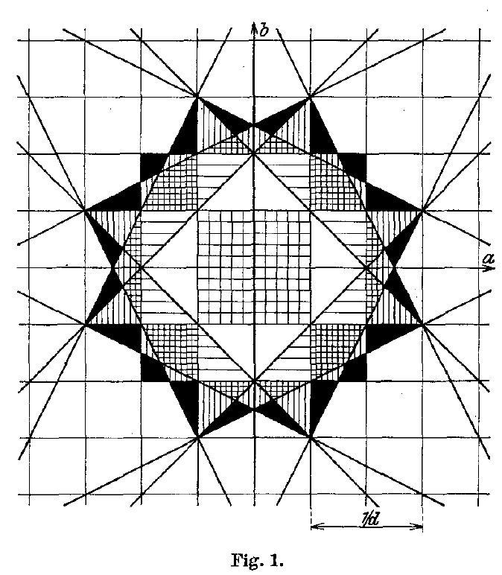**Exercise:**  The figure below is a depiction of Brillouin-zone boundaries from a 1932 paper <https://doi.org/10.1007/BF01339581> by Ralph Kronig who proposed one of the first theories explaining EXAFS based on the behavior of a photoelectron traveling through a periodic crystal lattice. Give the printing restrictions of the time, each region had to be textured with a different pattern of horizontal and vertical lines. Color in each unique textured region with a corresponding unique color.